GEMÜ 650 with attachment GEMÜ 1010
18 June 2012

Page 1/2

Marketing | Dagmar Alberti
Tel.: +49 (0) 7940 123-467 | Fax: +49 (0) 7940 123-487 | dagmar.alberti@gemue.de

Marketing | Eva Zink | Coordination Public Relations
Tel.: +49 (0) 7940 123-708 | Fax: +49 (0) 7940 123-487 | eva.zink@gemue.de

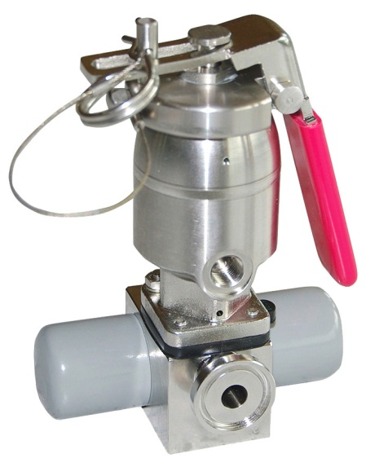
GEMÜ 650 with attachment GEMÜ 1010:
Dead man’s handle for sterile valve applications
GEMÜ, as the leading manufacturer of aseptic diaphragm valves, has extended its product range in sampling valves to meet market requirements. A valve attachment GEMÜ 1010 is being provided for the valves with diaphragm size 8 (DN4 to DN15) and will be available from July 2012.
In comparison with conventional sampling valves where a handwheel is used, operation is now uncomplicated, involving only a hand lever. This makes quick sampling possible with only one hand movement. In addition it operates as a ”dead man‘s handle” – automatically closing the valve when released.
GEMÜ 650 with attachment GEMÜ 1010
The definite closing force of the valve is an additional benefit, because it also significantly increases the service life of the diaphragm.
In addition, in order to lock the valve, a spring cotter pin is used to prevent unintentional operation of the lever. There is also a ‘hold-open’ function which allows autoclaving of the entire valve.

GEMÜ Background Information
GEMÜ 650 with attachment GEMÜ 1010

GEMÜ is one of the world’s leading manufacturers of valves, measurement and control systems. Since 1964, this globally focused, independent family-owned enterprise has established itself in important industrial sectors thanks to its innovative products and customised solutions for process media control. GEMÜ is the world market leader for sterile valve applications in the pharmaceutical and biotechnology industries.
Today, the GEMÜ Group employs over 680 employees in Germany and more than 1,270 employees worldwide. Manufacturing is carried out in six production companies in Germany, Switzerland, China, Brazil, France and the USA. From Germany we coordinate global marketing with 20 subsidiaries. With a large distributor network in 53 markets, the GEMÜ group is present on all five continents. GEMÜ will continue to establish itself in future markets with its international growth strategy. This will be achieved by the opening of a new Assembly and Logistics Centre in Germany in 2013, and in Switzerland and China the production capacities will be greatly expanded from 2012.
A broad based modular system and adapted automation components mean that predefined standard products and customised solutions can be combined to make over 400,000 product versions.
Further information can be found at www.gemu-group.com.

